**Expansion of gas into vacuum**

***Comparing the predictions of the model to the experimental results***

We measure the expansion of gas into vacuum with a video camera: We measure the brightness in a specific region and generate graphs of the brightness vs. position and time.

1. Here are graphs of the brightness vs. position that were measured at three times along the region marked in black in the upper container of the experimental apparatus (see the pictures in the table)

|  |  |  |  |
| --- | --- | --- | --- |
|  |  |  | ***Experimental apparatus*** |
|  |  |  | ***Brightness-position*** |
| $$2s$$ | $$1.5s$$ | $$0s$$ | **Time** |

Here are results of running a simulation of a hard-sphere gas, and a histogram of the density of particles at three times. Download the file from [this link](https://app.box.com/s/0afq29979774wmkx0ljstec7gvqdmmbf), run it, and watch the development of the system.

|  |  |  |  |
| --- | --- | --- | --- |
|  |  |  | ***Simulation*** |
|  |  |  | ***Density-position*** |
| $$2s$$ | $$1.5s$$ | $$0s$$ | **Time** |

Use the following table to **compare the graphs obtained from the predictions of the model with the graphs obtained from experimental results** at different stages of the development of the system – dynamics and equilibrium. **Relate your comparisons to the microscopic (particle) and macroscopic views** of the system.

|  |  |  |  |
| --- | --- | --- | --- |
|  | ***What’s the same?*** | ***What’s different?*** | ***What are the reasons for the differences?*** |
| ***Dynamics*** |  |  |  |
| ***Equilibrium*** |  |  |  |

1. 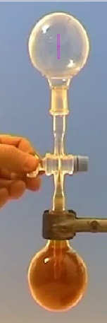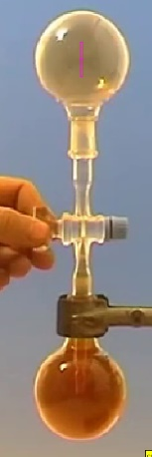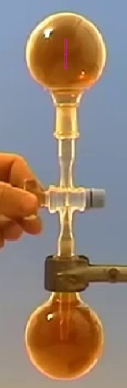Below is a graph of brightness vs. time that was measured at the center of the area indicated in black in the upper container of the experimental apparatus (the point of measurement is indicated with an arrow in the picture that appears below).

$$t=2s$$

$$t=0s$$

$$t=1.5s$$

Below are results of running the hard-sphere gas simulation, and a graph of particle density that was produced with local monitors at the center of the container. Download the simulation file from [this link](https://app.box.com/s/0afq29979774wmkx0ljstec7gvqdmmbf), run it, and watch the development of the system.

.

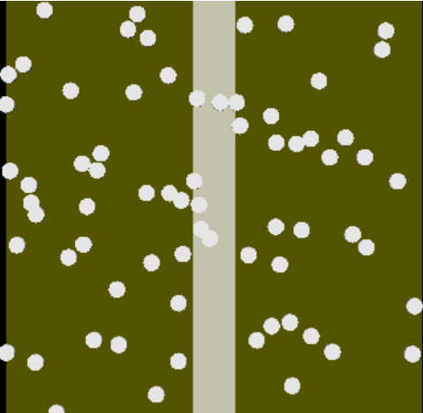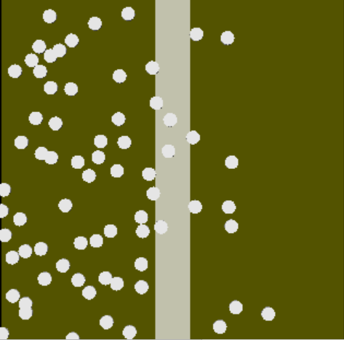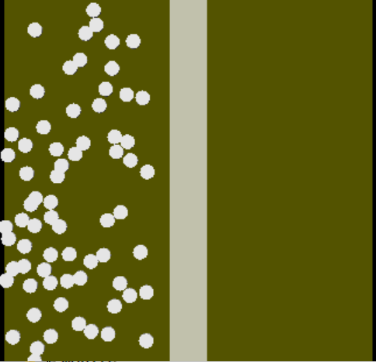

$$t=0.1s$$

$$t=0.15s$$

$$t=0s$$

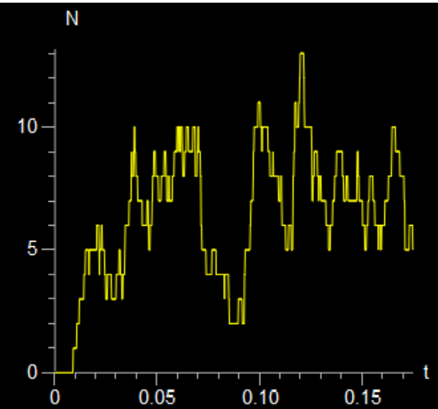

Use the following table to **compare the graphs obtained from the predictions of the model with the graphs obtained from experimental results** at different stages of the development of the system – dynamics and equilibrium. **Relate your comparisons to the microscopic (particle) and macroscopic views** of the system.

|  |  |  |  |
| --- | --- | --- | --- |
|  | ***What’s the same?*** | ***What’s different?*** | ***What are the reasons for the differences?*** |
| ***Dynamics*** |  |  |  |
| ***Equilibrium*** |  |  |  |